PERQUIMANS COUNTY
WALLACE E. NELSON
CHAIRMAN
CHARLES WOODARD
VICE CHAIRMAN
TIMOTHY J. CORPREW
JOSEPH W. HOFFLER
KATHRYN M. TREIBER
JAMES W. WARD
W. HACKNEY HIGH, JR.
COUNTY ATTORNEY
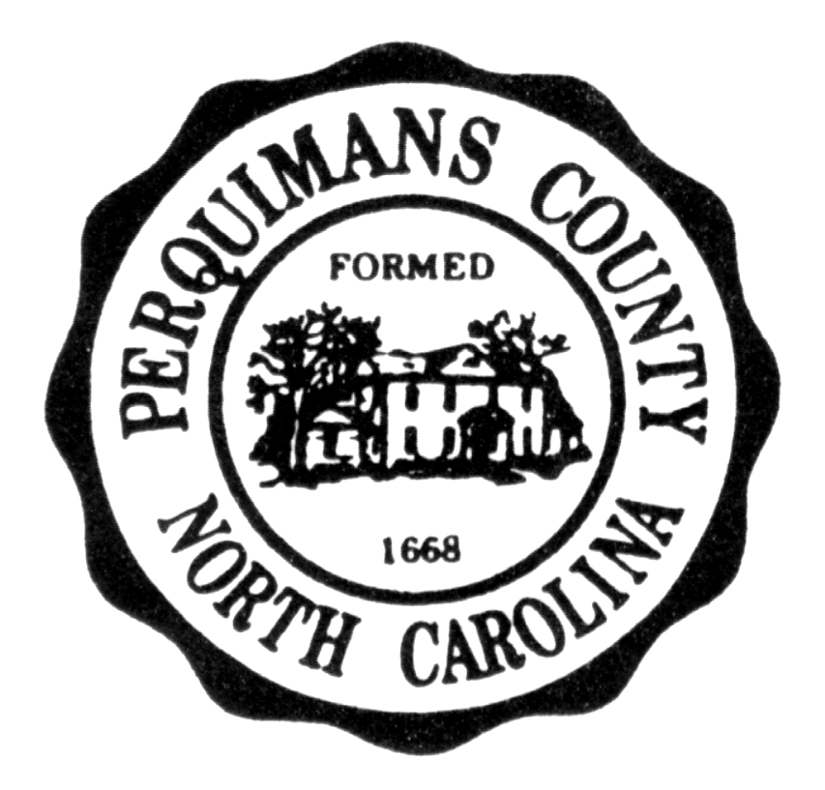
BOARD OF COMMISSIONERS

P.O. BOX 45
HERTFORD, NORTH CAROLINA 27944
TELEPHONE: 1-252-426-7550

MARY P. HUNNICUTT

CLERK TO BOARD

W. FRANK HEATH, III

COUNTY MANAGER

P U B L I C N O T I C E

Pursuant to NC General Statute 143-318.11(4), the Perquimans County Board of Commissioners will hold a SPECIAL CALLED MEETING on Monday, March 17, 2025, at 7:00 p.m. in the Meeting Room of the Perquimans County Library located at 514 S. Church Street, Hertford, North Carolina. The purpose of the Special Called Meeting is to discuss a lease agreement for property located in the Marine Industrial Park. The Board may take action on this item and, at its discretion, may take action on such other matters, as the Board deems appropriate. The Work Session usually scheduled after the Special Called Meeting has been cancelled.
Frank Heath
Frank Heath, County Manager

Posted: March 13, 2025

